

Network Lab Report

ASSIGNMENT- 4



JADAVPUR UNIVERSITY

NAME – SOULIB GHOSH

SECTION – A2

CLASS - BCSE – III

ROLL – 0016105010 47

**Submission** – 28th March

**Problem Statement**

In this assignment you have to implement CDMA for multiple access of a common channel by n stations. Each sender uses a unique code word, given by the Walsh set, to encode its data, send it across the channel, and then perfectly reconstruct the data at n stations.

**Introduction:**

The Data Link Layer is responsible for transmission of data between two nodes. Its main functions are- Data Link Control and Multiple Access Control. The data link control is responsible for reliable transmission of message over transmission channel by using techniques like framing, error control and flow control. If there is a dedicated link between the sender and the receiver then data link control layer is sufficient, however if there is no dedicated link present then multiple stations can access the channel simultaneously. Hence multiple access protocols are required to decrease collision and avoid crosstalk. For example, in a classroom full of students, when a teacher asks a question and all the students (or stations) start answering simultaneously (send data at same time) then a lot of chaos is created (data overlap or data lost) then it is the job of the teacher (multiple access protocols) to manage the students and make them answer one at a time. Thus, protocols are required for sharing data on non-dedicated channels. Multiple access protocol is divided into three categories – Random Access, Controlled Access and Channelization. In random access no node has control over other nodes. Every nodes randomly try to send the data after checking the medium is free or not. To avoid collision many collision avoidance and collision detection techniques are used. In this, all stations have same superiority that is no station has more priority than another station. Any station can send data depending on medium’s state (idle or busy). It has two features: There is no fixed time for sending data and there is no fixed sequence of stations sending data. In controlled access each node has control over all other node or there is a primary node which controls all the secondary nodes. In controlled access, the stations seek information from one another to find which station has the right to send. It allows only one node to send at a time, to avoid collision of messages on shared medium. In channelization, each node is given a specific domain to transfer the data so, there is no question of controlling other nodes or collision avoidance algorithm. Channelization is divided into three groups – FDMA, TDMA and CDMA. In FDMA, the entire bandwidth is divided into several frequency domain which is used each nodes. In TDMA, time is divided into several slots an each slot is divided by each node. CDMA divides the domain by using some special type of codes generated from Walsh table. The exact procedure of CDMA is discussed later.

**Overview of CDMA:**

The CDMA process is based on the Walsh table. So let us discuss the Walsh table first. Then data encryption and decryption technique is discussed.

**Walsh Table:**

Walsh table is a square matrix consisting of only -1 or +1. Size of Walsh table is always in power of two. Let us consider a Walsh table of size N*N. We can obtain total N codes each of size N. If the number of user M is not power of two then we need to create Walsh table of size N which is next power of two and select any M rows from that.

Walsh table maintains two basic properties which are the pillar of the concept. Let two rows in Walsh table be $X_{i}$ and $X_{j}$ Then,

$X_{i}* X_{j}=0$

$X_{i}* X_{i}=N$

Here product is same as vector dot product.

Walsh table is generated in a recursive way mentioned below. Let us consider a Walsh table of size N named W. Then the Walsh table of size 2N is given by:

$$W_{2N}= \begin{matrix}W & W \\ W & \overline{W}\end{matrix}$$

$\overline{W}$ is the complement of $W$ where the +1 is converted to -1 and the -1 is converted to +1. The base case is when Walsh table is of size one which contains only one +1.

**Data Encryption Technique:**

Let us assume that the number of nodes are N. In CDMA in one attempt each node can receive and send one bit data. If a node wants to send bit 1 then data bit is +1, bit 0 then -1 and if don’t want to send data then it remains silent using data bit 0.

For each node let us assume that the data bit is $D_{i}$ and the corresponding code is $C_{i}$ which is obtained from Walsh table. We calculate ${ D}_{i}* C_{i}$ for each sender node. The final data D which is to be send in the channel is given by:

$$D= \sum_{i=1}^{N}{{ D}_{i}* C_{i}}$$

**Data Decryption Technique:**

Suppose a station ${ S}_{i}$ wants to retrieve the data send by station ${ S}_{j}$ then the station ${ S}_{i}$ must have the code of ${ S}_{j}$ which is ${ C}_{j}$. Now we compute ${ D* C}_{j}$. If we observe carefully the two properties of Walsh table, then it can be concluded that the result will become $N*D_{j}$ as the other multiplications will be zero. In the later step we divide the result by N to obtain the desired data as we know the value of N beforehand or can be computed from the size of the code.

**Advantages of CDMA:**

CDMA has a soft capacity. The greater the number of codes, the more the number of users. It has the following advantages –

* CDMA requires a tight power control, as it suffers from near-far effect. In other words, a user near the base station transmitting with the same power will drown the signal latter. All signals must have more or less equal power at the receiver.
* Rake receivers can be used to improve signal reception. Delayed versions of time (a chip or later) of the signal (multipath signals) can be collected and used to make decisions at the bit level.
* Flexible transfer may be used. Mobile base stations can switch without changing operator. Two base stations receive mobile signal and the mobile receives signals from the two base stations.
* Transmission Burst − reduces interference.

**Disadvantages of CDMA:**

The disadvantages of using CDMA are as follows –

* The code length must be carefully selected. A large code length can induce delay or may cause interference.
* Time synchronization is required.
* Gradual transfer increases the use of radio resources and may reduce capacity.
* As the sum of the power received and transmitted from a base station needs constant tight power control. This can result in several handovers.

**Overview of the Proposed Implementation:**

The proposed module is viewed as three subparts. One is data encryption part, second one is channel and the third one is data decryption part. For the data encryption part first of all Walsh table is generated. We obtain the data based on the send bit by each sender. Then we follow the above mentioned process to obtain the channel data. The channel data is considered a variable in this case. That variable is accessed by each receiver node. Then we follow the data decryption procedure mentioned above to get hold of the final received data. In the data decryption process we have assumed that the receiver end have the Walsh code as required for the decryption process. The schematic diagram of the proposed approach is given in Figure 1.

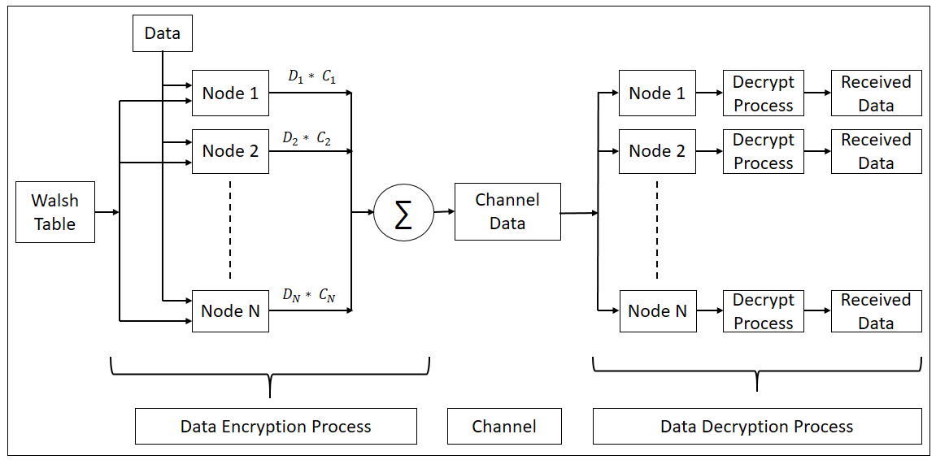

Figure 1: Overview of the proposed approach.

**Code Snippet:**

This function creates the Walsh table of a variable size. It takes the dimension of the Walsh matrix and provides the Walsh matrix for the mentioned dimension.

1. function [out]=walse_table(codeSize)
2. siz = codeSize;
3. codeSize = pow2(ceil(log2(codeSize)));
4. N=2;
5. H=[0 0 ; 0 1];
6. **while**(N~=codeSize)
7. N=N*2;
8. H=repmat(H,[2,2]);
9. [m,n]=size(H);
10. **for** i=m/2+1:m
11. **for** j=n/2+1:n
12. H(i,j)=~H(i,j);
13. end
14. end
15. end
16. [r,c] = size(H);
17. **for** i = 1:r
18. **for** j = 1:c
19. **if** H(i,j) == 0
20. H(i,j) = 1;
21. **else**
22. H(i,j) = -1;
23. end
24. end
25. end
26. out = [];
27. **for** i = 1:siz
28. out = [out; H(i,:)];
29. end
30. end

The function ‘generate_data’ calculate the data which is to be send through the medium. The generated data will be received by every stations. This function takes the entire code list and the data list as input. The output is the data array of Walsh code size which is to be transferred via medium.

1. function [data_out] = generate_data(code_list,data)
2. %UNTITLED3 Summary of **this** function goes here
3. %   Detailed explanation goes here
4. len = length(data);
5. **for** i = 1:len
6. code_list(i,:) = code_list(i,:)*data(i);
7. end
8. data_out = sum(code_list);
9. end

The function ‘decrypt data’ calculates the embedded data using the respective Walsh code. It takes the channel data and the Walsh code as input and outputs the decrypted data which is to be extracted by the specific station.

1. function [data] = decrypt_data(channel_data,code)
2. %UNTITLED5 Summary of **this** function goes here
3. %   Detailed explanation goes here
4. data = sum((channel_data.*code))/length(code);
5. end

**Example Test Case and its Output:**

Suppose we have four nodes. Node 1 and Node 2 want to send bit 0. Node 3 is silent. Node 4 wants to send bit 1. According to the process above data bit for the nodes will be -1, -1, 0 and 1 respectively.

We want the following test cases:

1. Node 3 receives the data send by Node 1.
2. Node 2 receives the data send by Node 4.

The output of the above problem is:

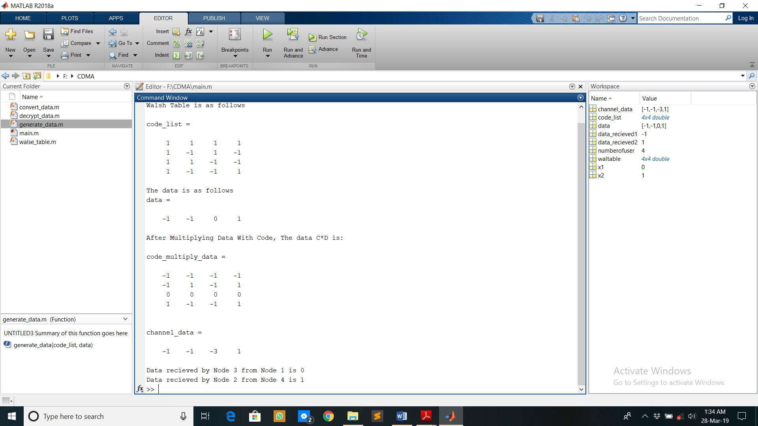

**Strength of the Method:**

Some strength of the proposed approach is as follow:

* 1. All the modules are separately created. We can modify or reuse some module is other works also.
  2. The method is designed for one bit data transfer. So, the proposed module can be called multiple times to implement any real life scenario where we can send and receive a bit stream.
  3. The channel is kept as a separate module. So we can apply any delay, noise separately in the channel without touching the other two module to study any practical situation.

**Weakness of the Method:**

Some weakness of the proposed method is as follows:

1. An original view of channel is missing in the implementation. The channel is considered as a variable which can be viewed as logical representation.

**Comments:**

The assignment is easy based on conceptual and implementation point of view. Specifically, in the view of implementation level, there were only few matrix operations which turned out to be very easy using MATLAB. In this assignment, I have learned the implementation details and the working principle of CDMA. The assignment would be considerable motivating if we can execute the sender and receiver in distinct device and communicate between two nodes. Then we could get a suitable existence of noise in the medium and channel delay.

******************************************END****************************************